Creating Storage Bucket for Signed URL Lab

1. Once you first log in, your screen should look similar to this.

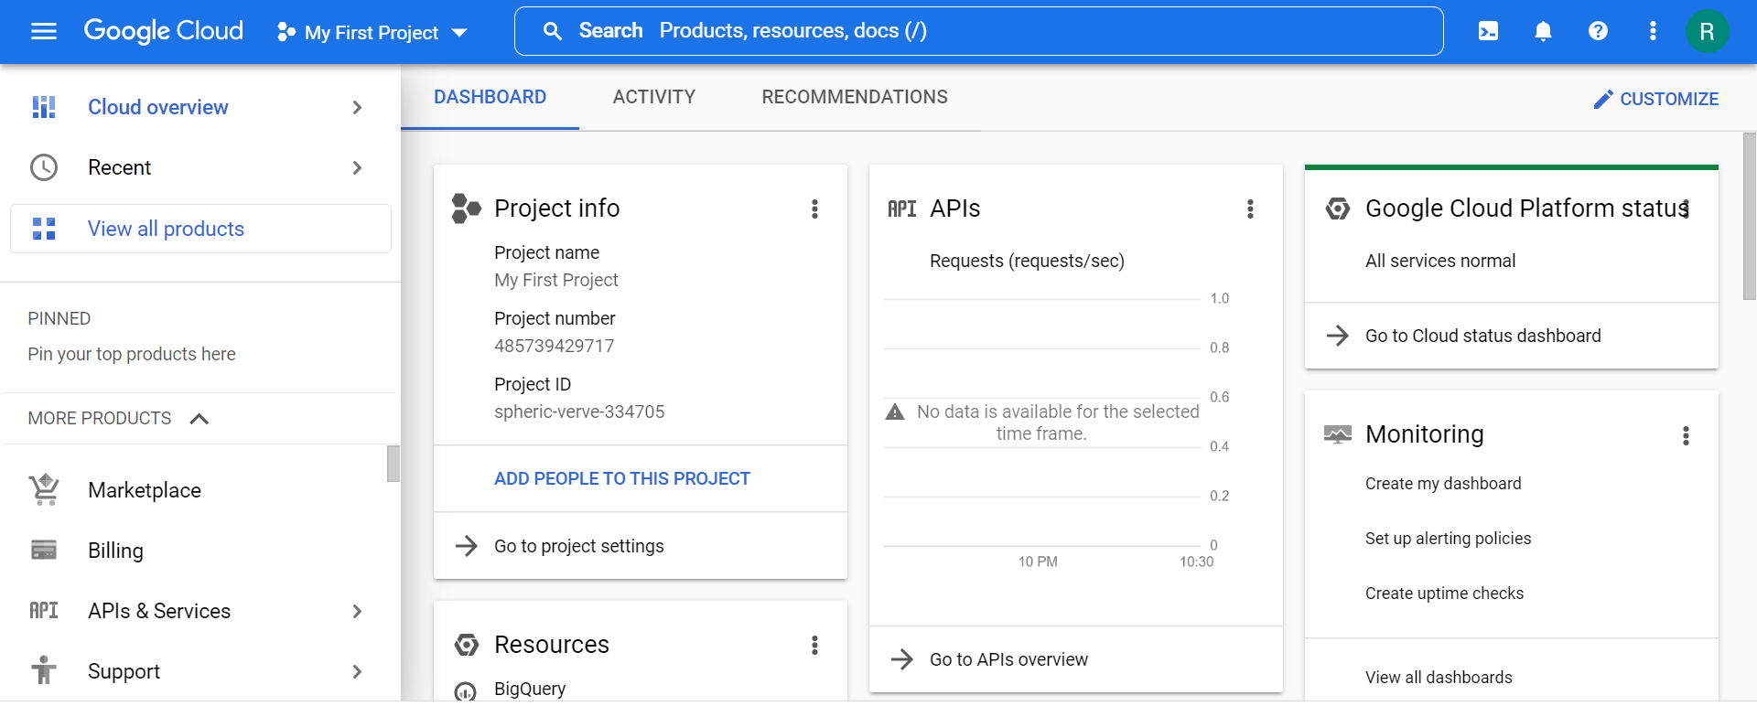

1. Click on the project selector drop-down menu at the top of the screen.

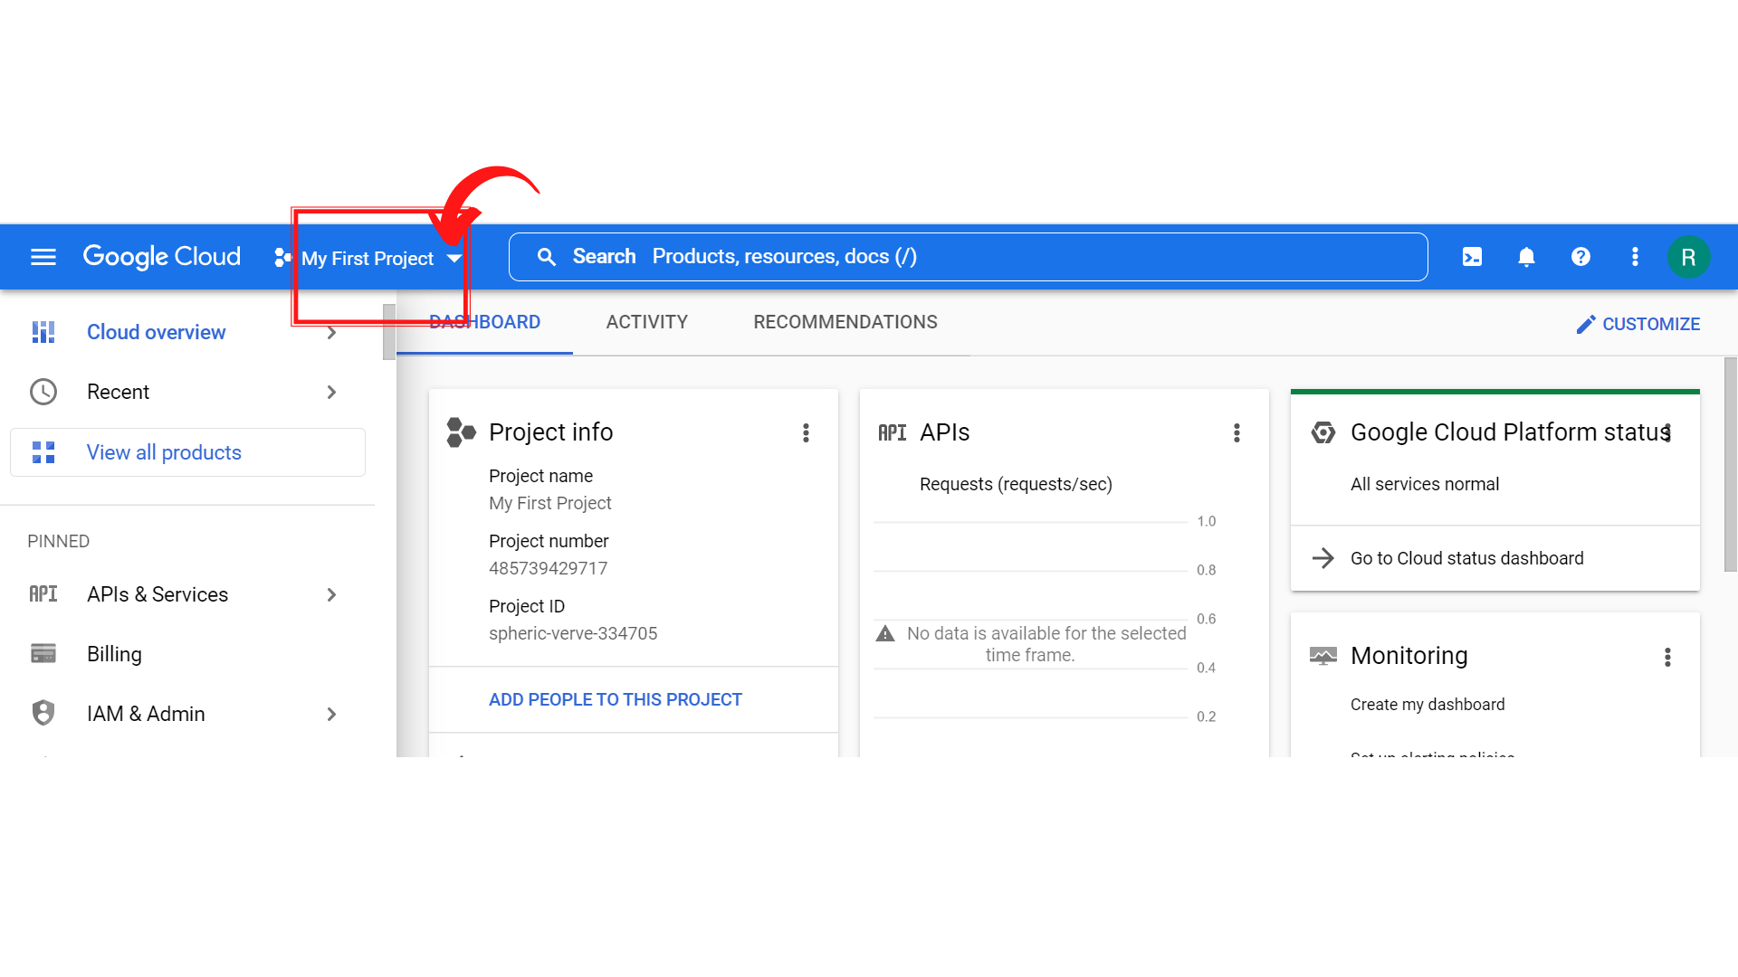

1. Since, we are doing labs on a Security Labs project, Click on *“Security Labs”*.

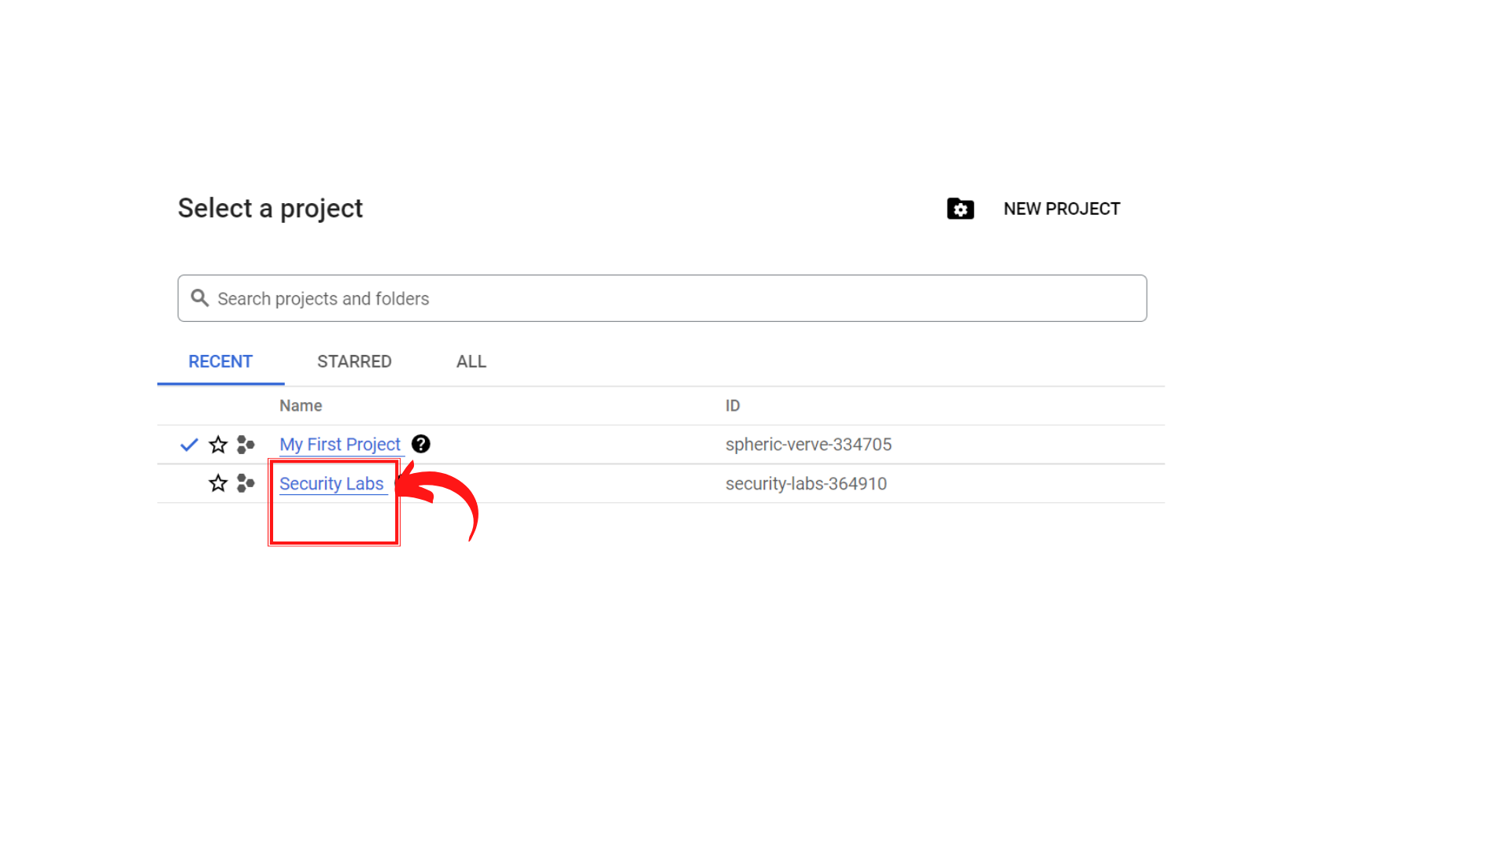

1. Your screen should look similar to this with project info changed to “*Security Labs”* project.

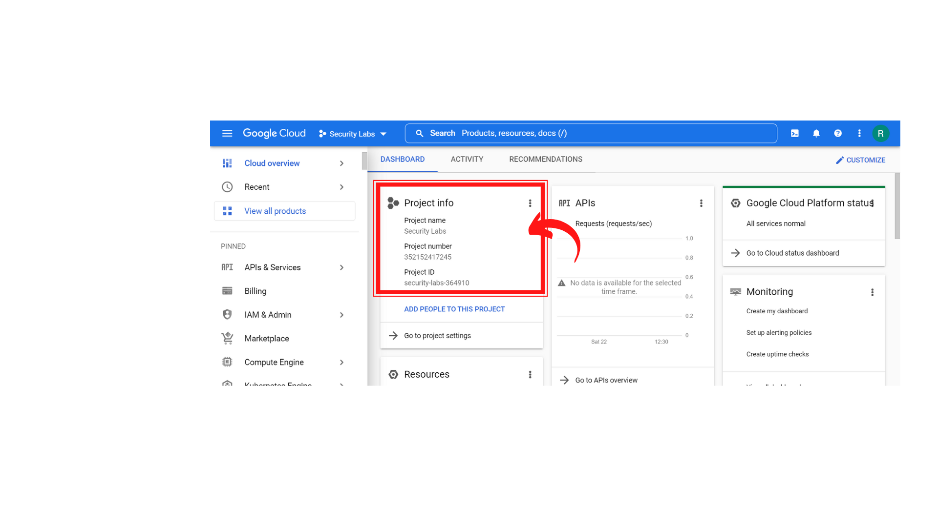

1. Click on *“Navigation menu”* on top left, then click on *“Cloud Storage” → “Buckets”*

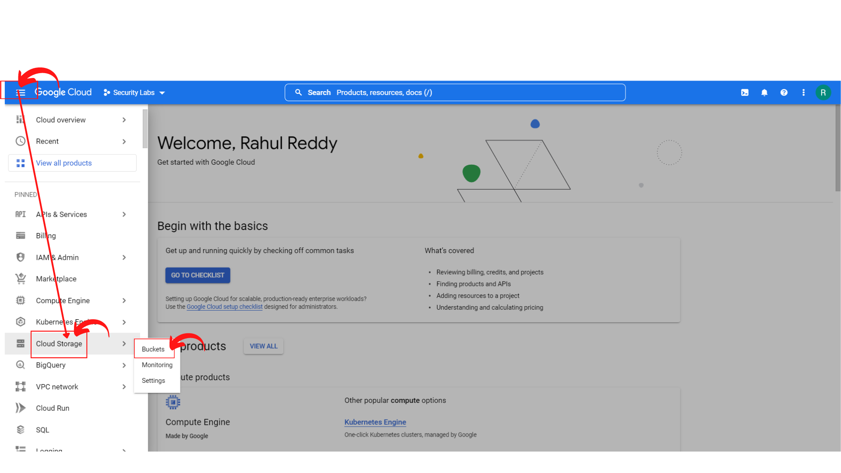

1. Your screen should look similar and click → *“Create”* or Click → *“Create Bucket”* to create a storage bucket.

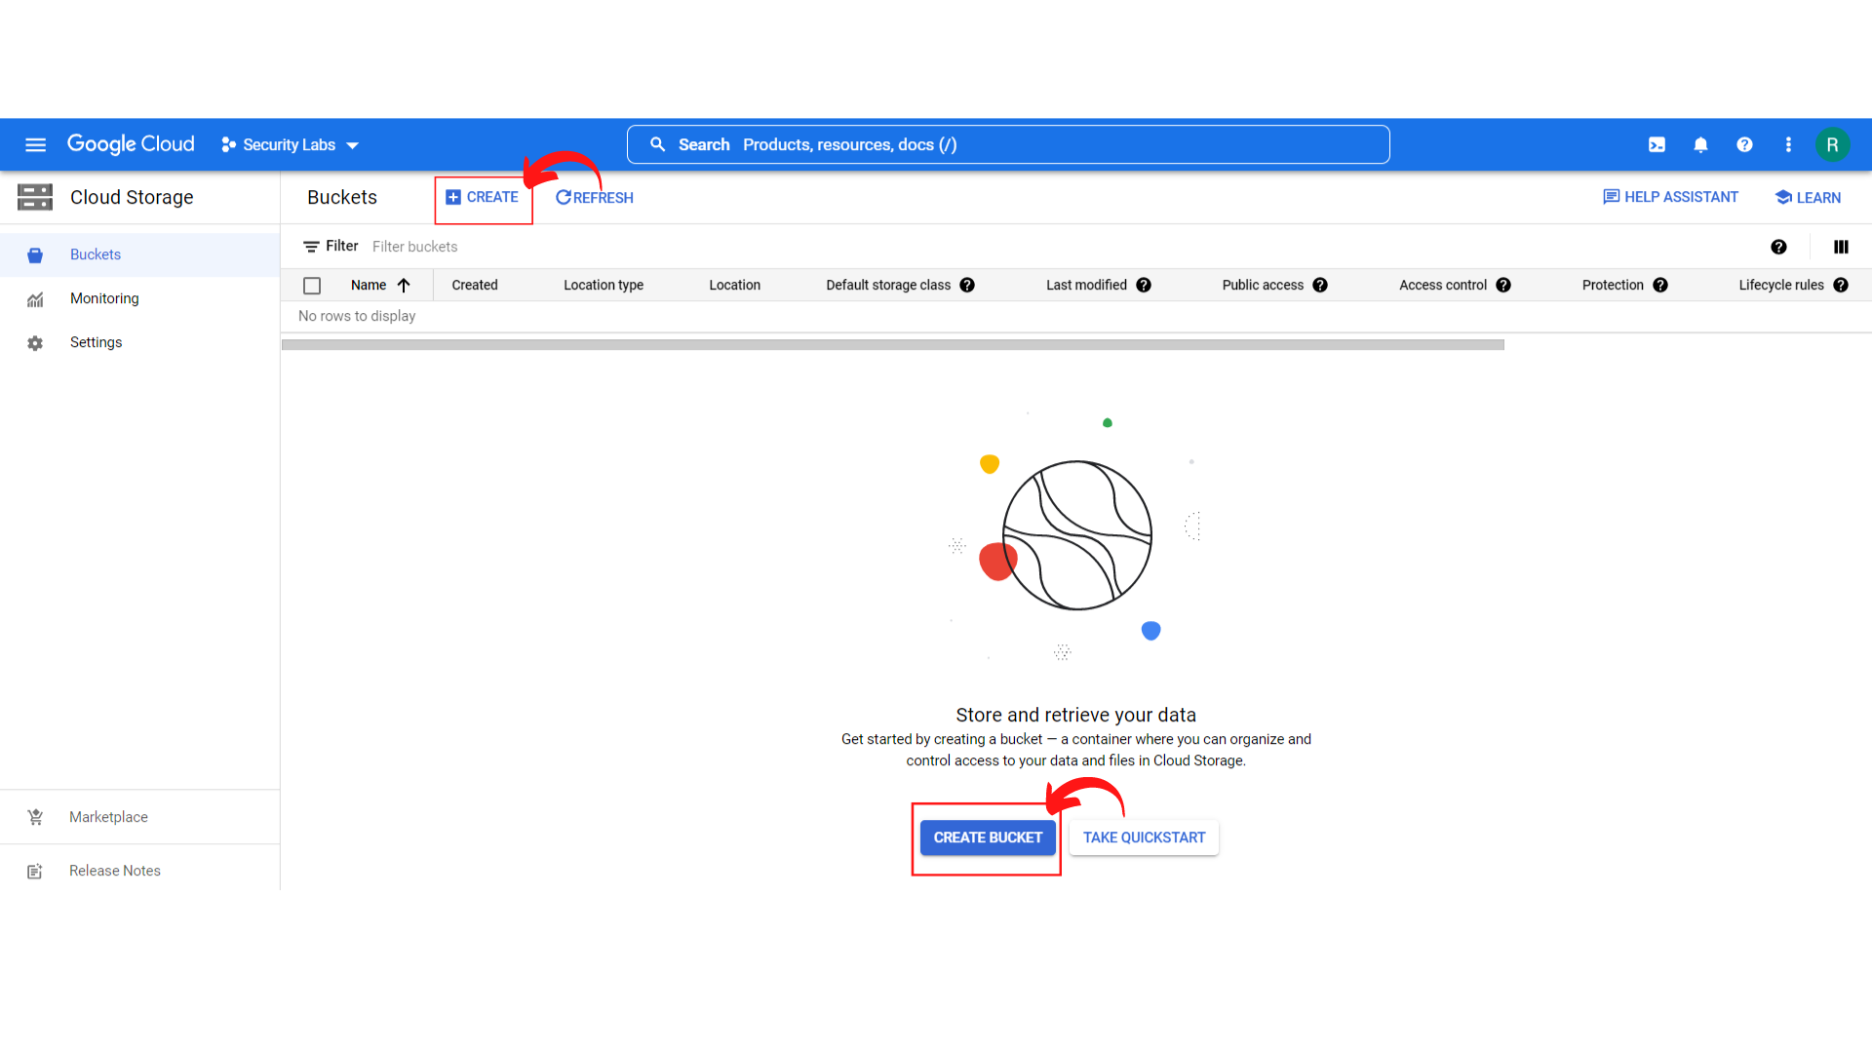

1. Your screen should look similar.

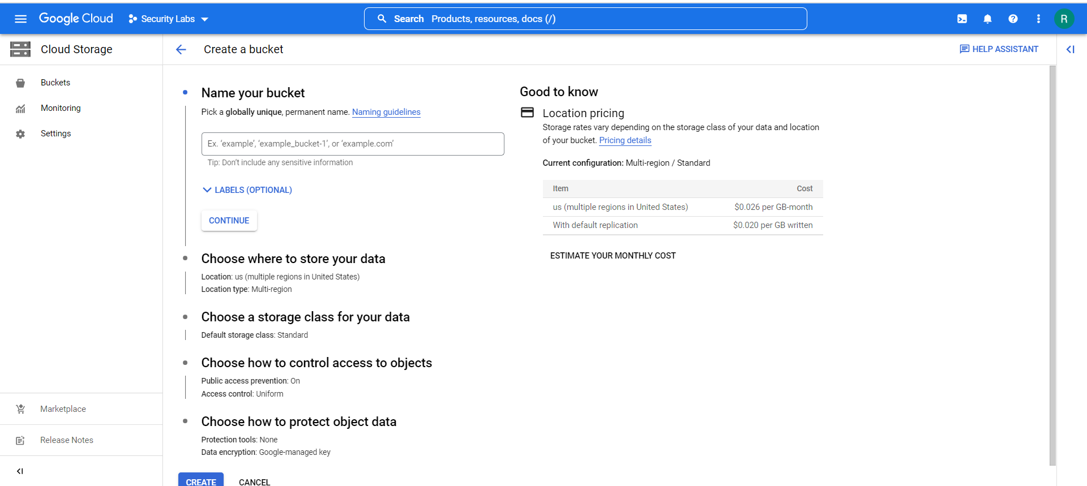

1. Now *Enter the Name of your Bucket* as per your choice and then *click → Continue*

Example: signed-url-lab

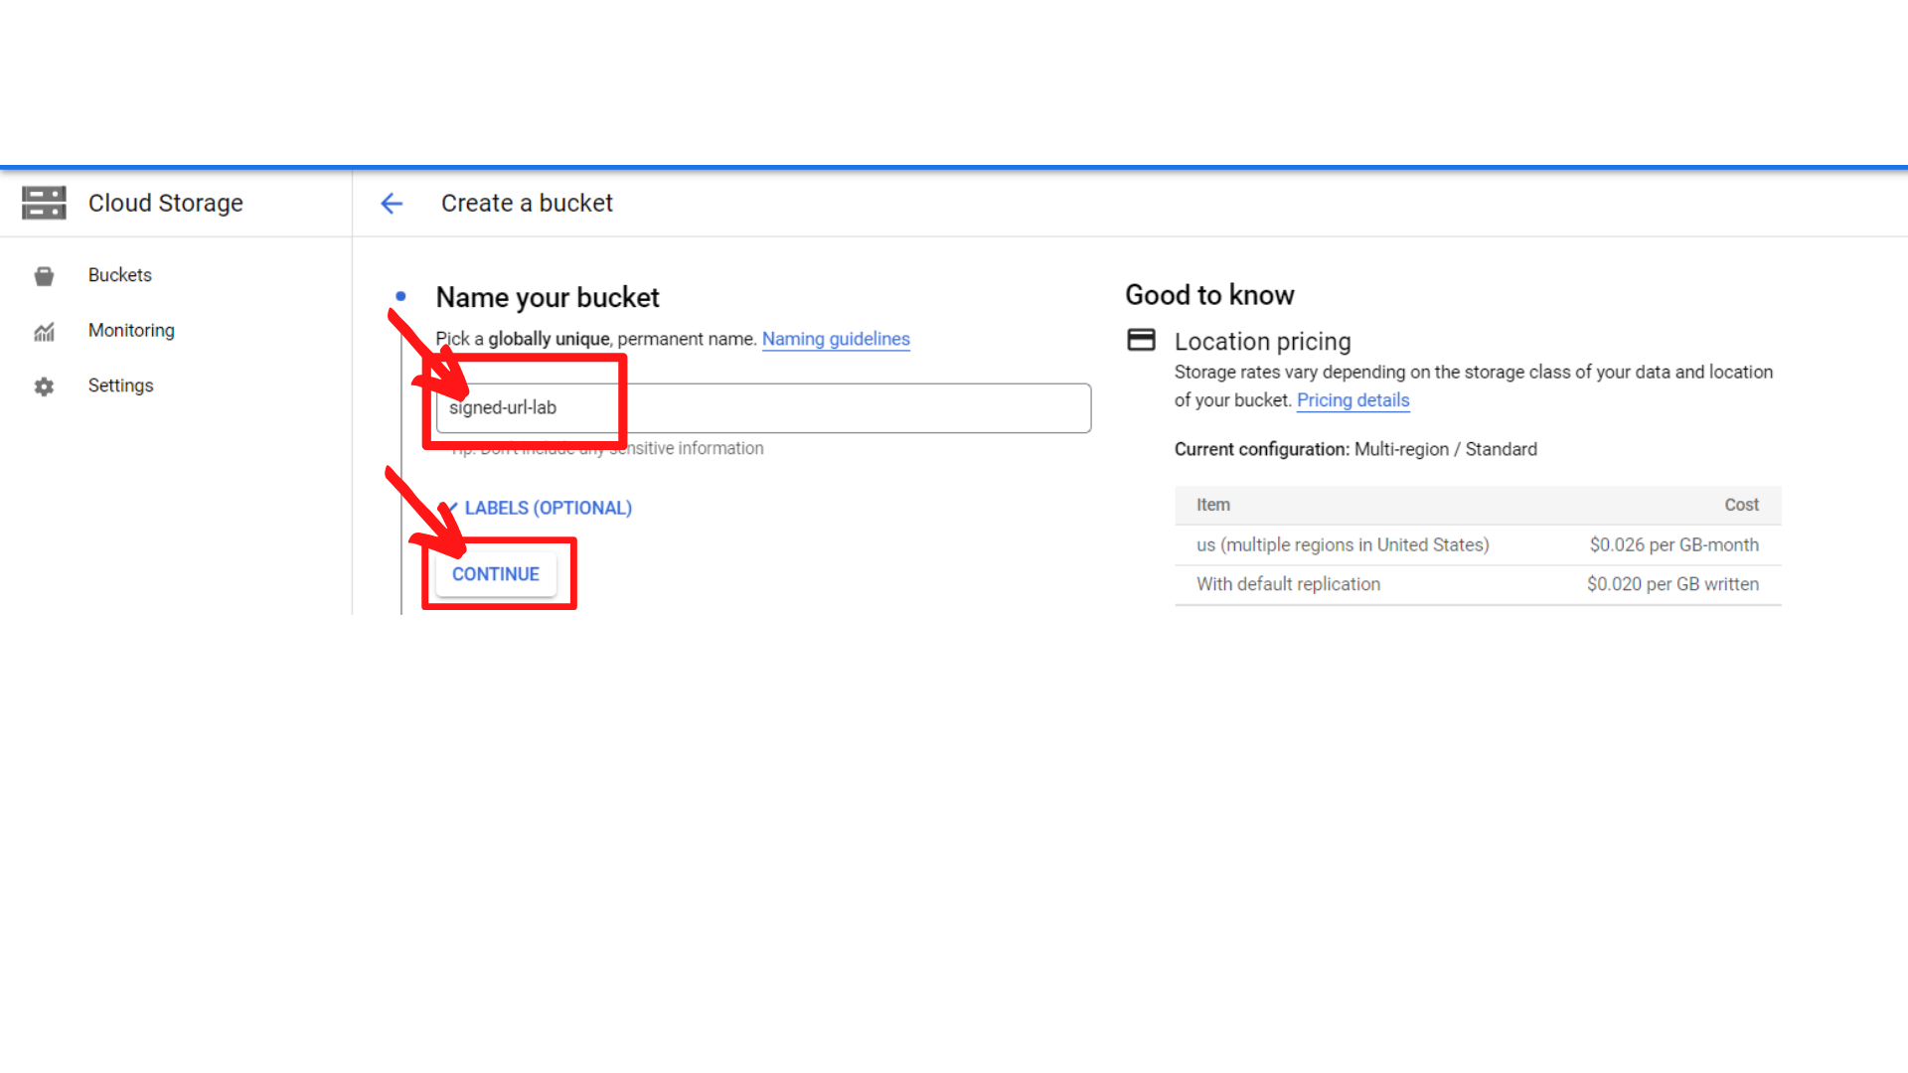

1. Now *Choose where to store your data* based on your region or any region you want and *“Click → Continue”*.

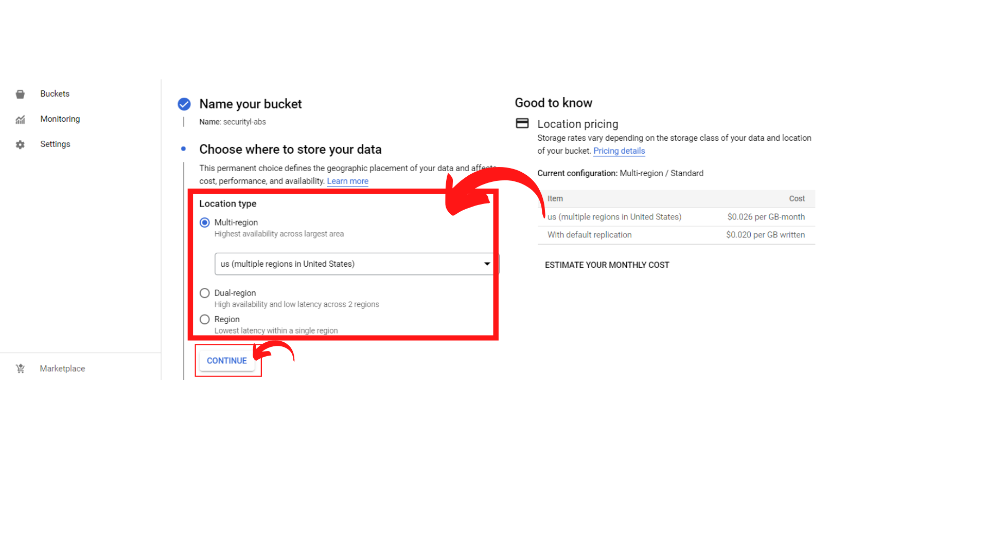

1. Now Choose a storage class for your data as per your choice and *“Click → Continue”*

Example: Here I’m leaving as default.

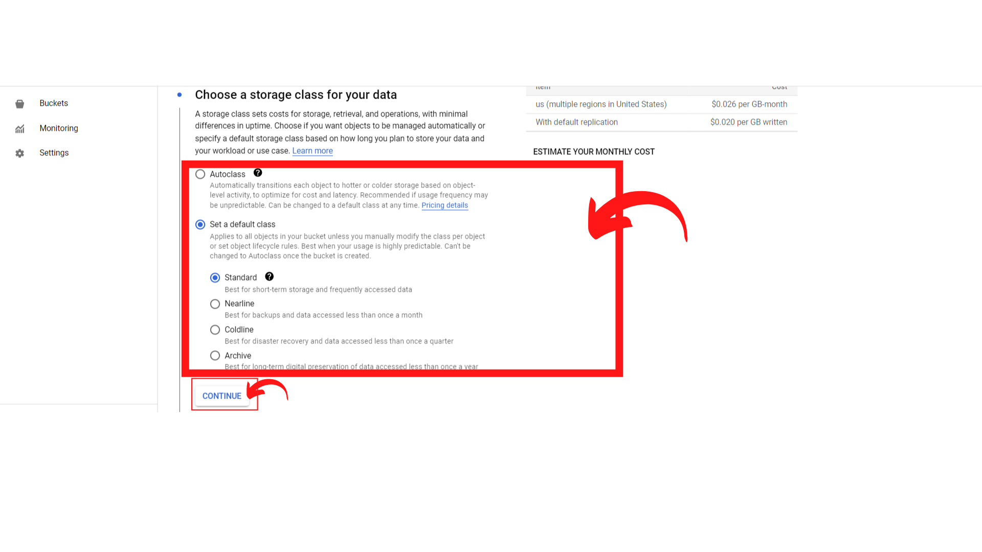

1. Now Choose how to control access to objects and *“Click → Continue”*

\*\*Restrict data from being publicly accessible via the internet. Will prevent this bucket from being used for web hosting.\*\*

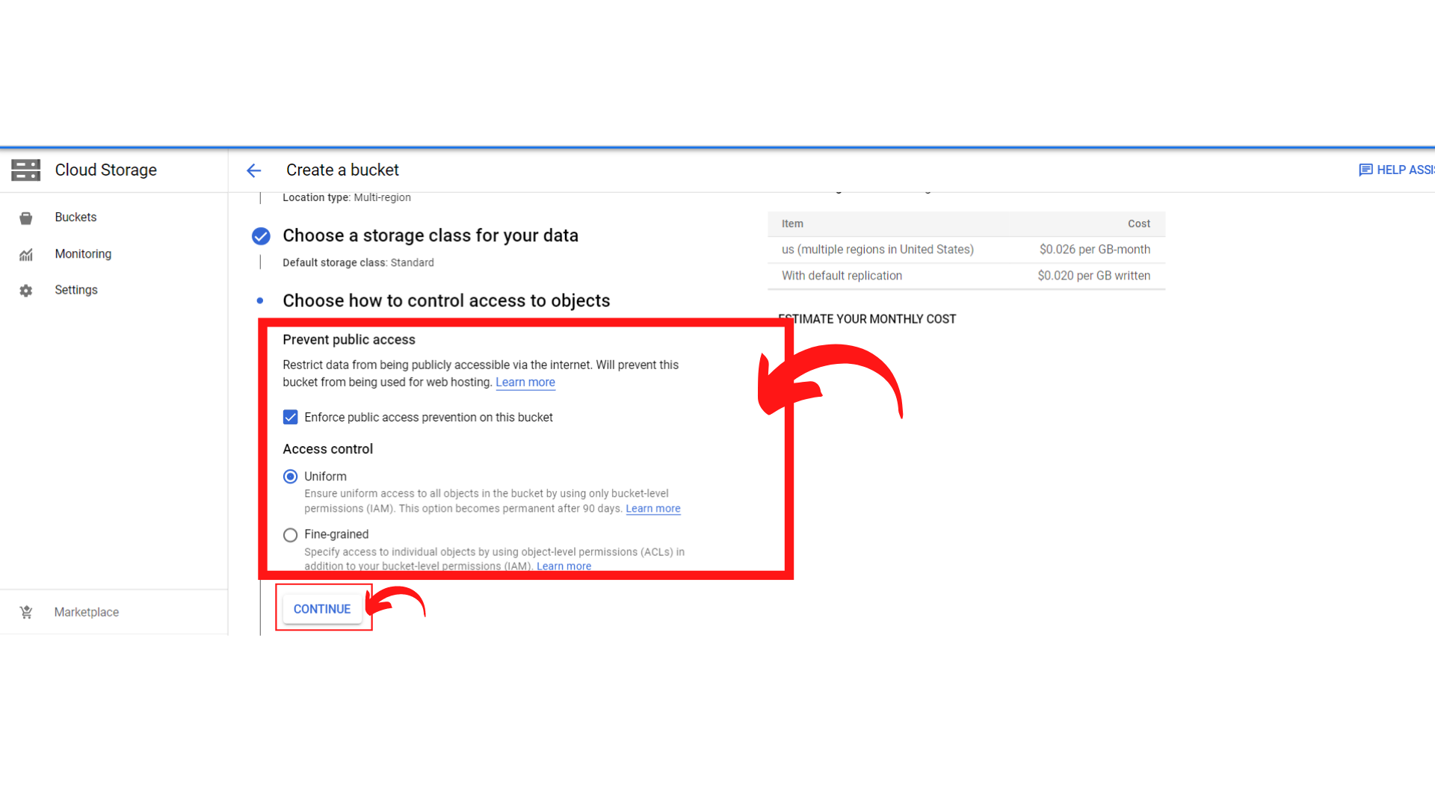

1. Now Choose how to protect object data and *“Click → Create”*

\*\*Your data is always protected with Cloud Storage but you can also choose from these additional data protection options to prevent data loss and you can also do Data encryption by Google Cloud Key Management Service or Google managed Encryption key.\*\*

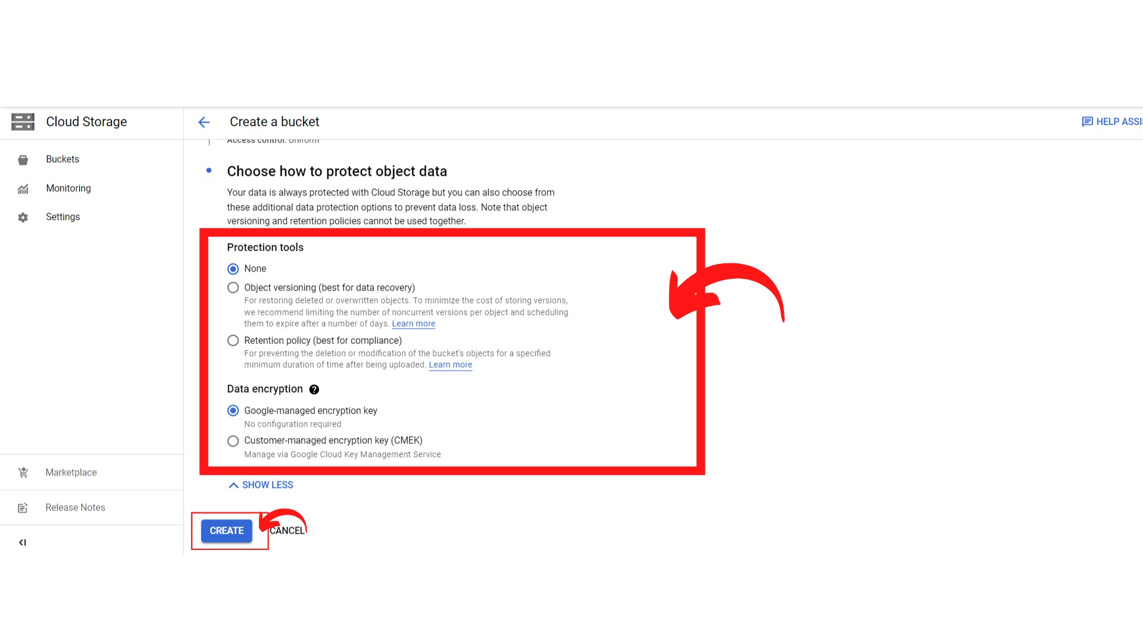

1. Then you get a notification to confirm “Public access will be prevented.” “Click → Confirm”

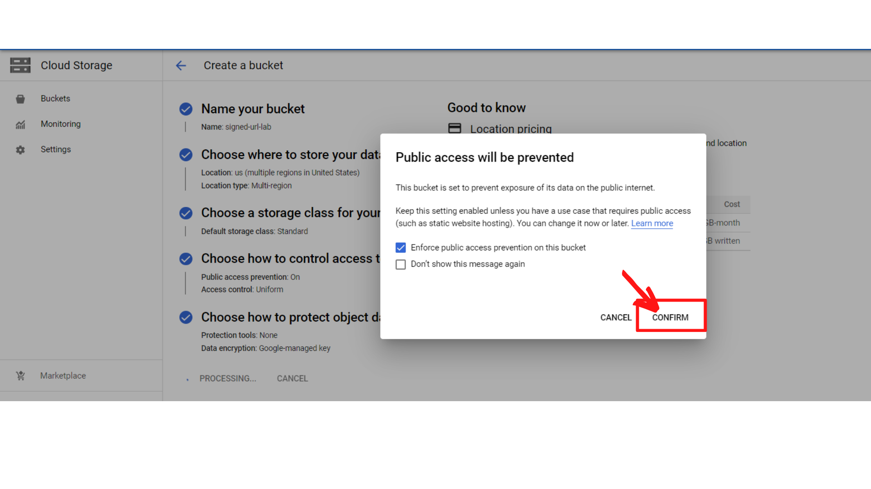

1. Your screen should look similar to this.

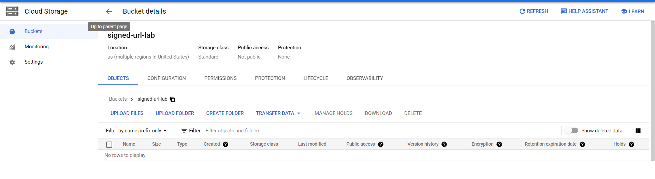

That’s it, you have successfully created a storage bucket for this Lab.